The Panther yearbook March 2017

# Congratulations,

## You have been recommended by your English teacher to join our award-winning team!

Yearbook has openings next year in key positions. **You have exhibited skills that make you an excellent candidate for one of these roles.** Your English teacher sees qualities in you that make you specifically qualified for our teams. You will be trained to work on our award-winning staffs. I look forward to working with you.

Did you know that yearbook **fills your art credit**?

Did you know that it **fills a tech credit**, too?

Do you like **to travel**? Do you like **winning awards**?

If so, sounds like **The Panther yearbook is for you**!

## Staff reporter/Graphic designer

Every staffer learns the basics of interviewing, reporting, writing and strong design. These journalism skills are the foundation of a quality storytelling and graphically pleasing publication.

## Business & marketing team leaders

A select team of leaders who concentrate solely on the financial well-being of the organization. The team obtains sponsors and advertisers, writes and gives presentations, promotes the publication and manages all financial aspects of our non-profit business.

## Web & social media specialist

Dedicated specialist who promotes book sales through social media tools (Instagram, SnapChat, Facebook, and Twitter). This student will also design our first website and work to promote our publication with sponsors and buyers.

## Photographer

A select position in second semester that submits photos only for all staffs based on assignments. No writing or design work associated with this position.

**YOUR TRAVEL SCHEDULE:**

* MIPA Summer Camp: July 30-August 3, 2017 Michigan State University (If interested, see Elizabeth Cyr asap)
* Summer 2017 Retreat: Swim . Plan . BBQ . Bonfire . Repeat
* MIPA Fall Conference: Lansing Center . October 2017
* JEA/NSPA National Conference, Dallas, Texas (Parent Meeting in August, 2017)
* MIPA One-Day Workshop: EdCamp at Michigan State . March 2018
* States! Division and All-State MIPA Awards Conference . Lansing Center. April 2018

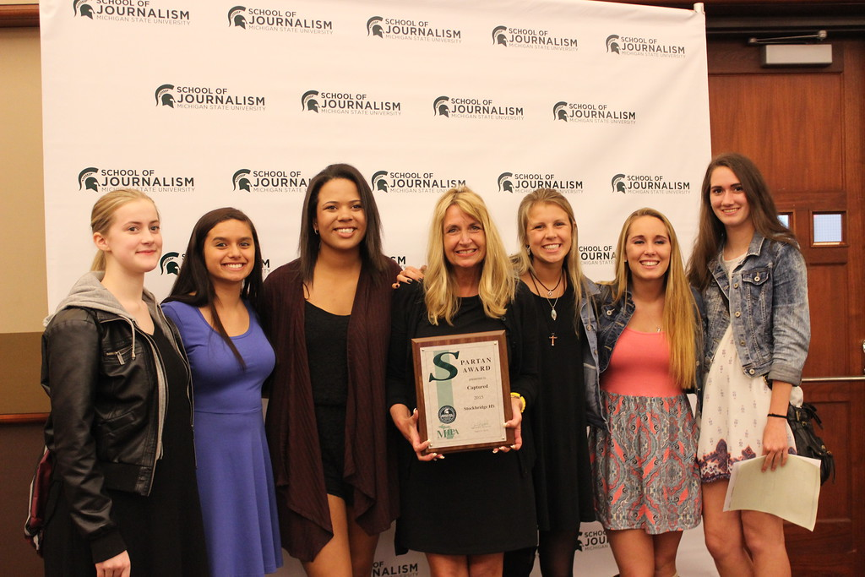

Peace, Elizabeth

Ms. Cyr, room 207, end of freshman hall

The Panther editorial team accepts the top award at states in April, the prestigious SPARTAN AWARD at the Lansing Center.

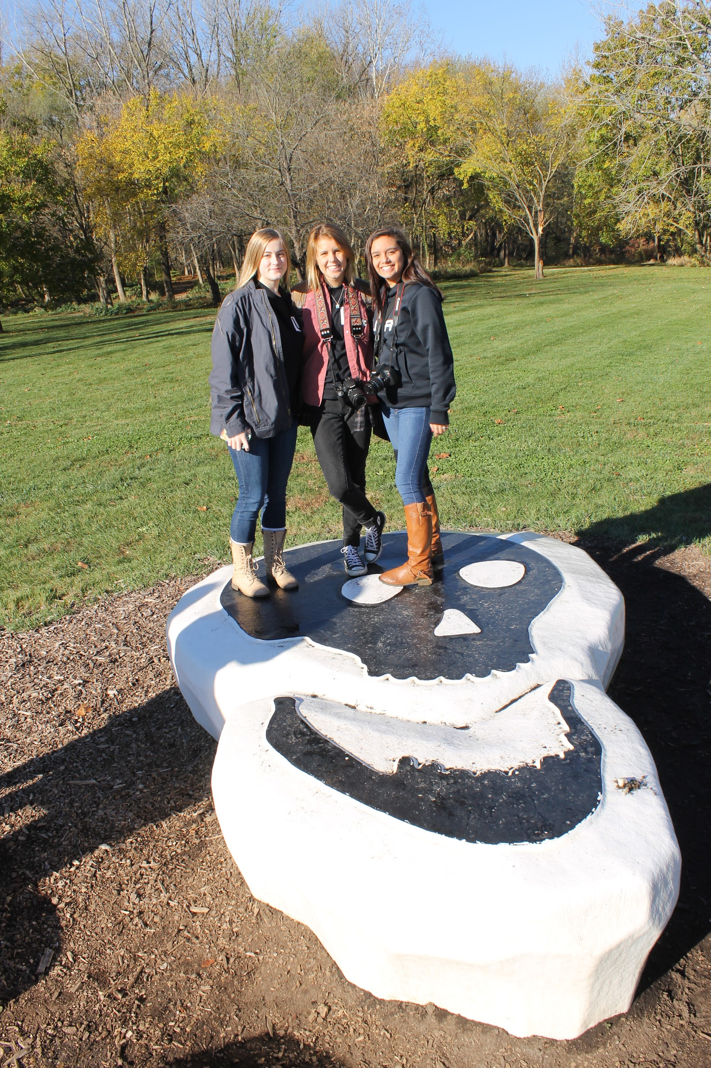

As a special media tour during the fall Journalism Education Association/National Scholastic Press Association Conference in Indianapolis, Indiana, the trio of editors-in-chief for The 2017 Panther yearbook enjoy time to share an afternoon touring the movie set of “The Fault in our Stars.” The team cheered on their fellow journalists on Uncaged later that week as they won the premier national award, the Pacemaker.